Purpose | Compare TensorRT Edge-LLM v0.9.0 runtime Decode throughput on Jetson Orin Nano 8GB with NVIDIA official v0.9.0 results.
PIC | SQA
Test Resource | By script (llm_inference)
Test Procedure | Test Instructions:  1. Use TensorRT Edge-LLM v0.9.0 and NVIDIA benchmark build limits.  2. Run MTBench / COCO, batch 1, warmup 10, and dumpProfile.  3. Record runtime Decode (tok/s); speculative rows use accepted-token throughput.  4. Compare all nine results with NVIDIA Jetson Orin Nano 8GB v0.9.0 values.  Benchmark Categories  Large Language Models (LLM) and Vision-Language Models (VLM):  Nine Qwen3 / Qwen3.5 entries covering Vanilla, EAGLE3, and MTP.  Performance Metrics  NVIDIA official Decode (tok/s) vs. local 23.101 Decode (tok/s)  Official Reference:  https://nvidia.github.io/TensorRT-Edge-LLM/user_guide/performance/performance-benchmarks.html
Test Location | PCP TW / 192.168.23.101
Pass Criteria | All nine models complete without error and each Decode result is within ±10% of NVIDIA official performance.
Configuration | DUT No. SOC BSP Version Edge-LLM Power / Clocks  23.101 Jetson Orin Nano 8GB JetPack 7.2 / R39.2 v0.9.0 / 1ac0f2b 15W: GPU 612 / EMC 2133 / CPU 1498 MHz
Test Result | Power Mode: 15W reproduction (GPU 612 MHz / EMC 2133 MHz)  Model NVIDIA Official 23.101 Local  Qwen3-0.6B (LLM) 72.8 66.2  Qwen3-1.7B (LLM) 37.4 35.8  Qwen3-1.7B (EAGLE3) 41.2 44.1  Qwen3-VL-2B (VLM) 36.9 36.6  Qwen3.5-0.8B (VLM) 55.3 53.4  Qwen3.5-0.8B (MTP) 45.0 46.8  Qwen3.5-0.8B-LLM 55.4 52.6  Qwen3.5-2B (VLM) 29.9 30.5  Qwen3.5-2B-LLM 30.0 30.2  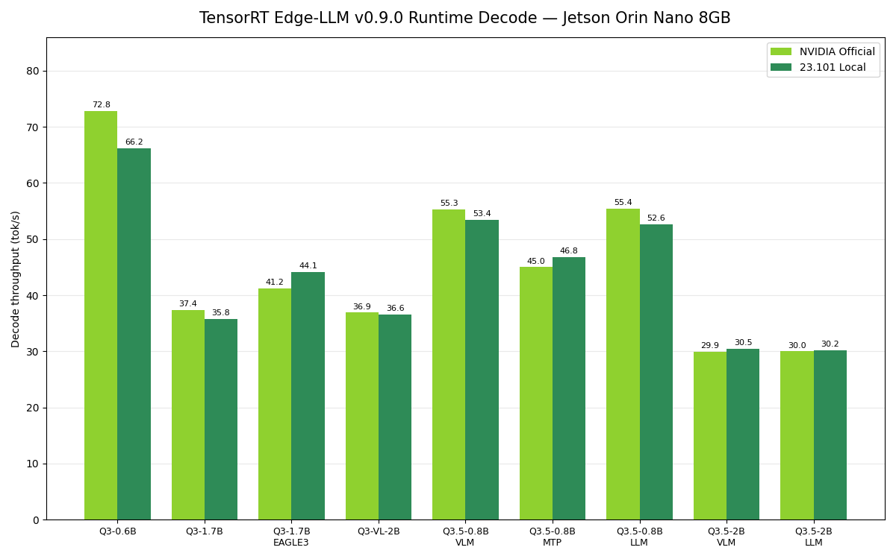  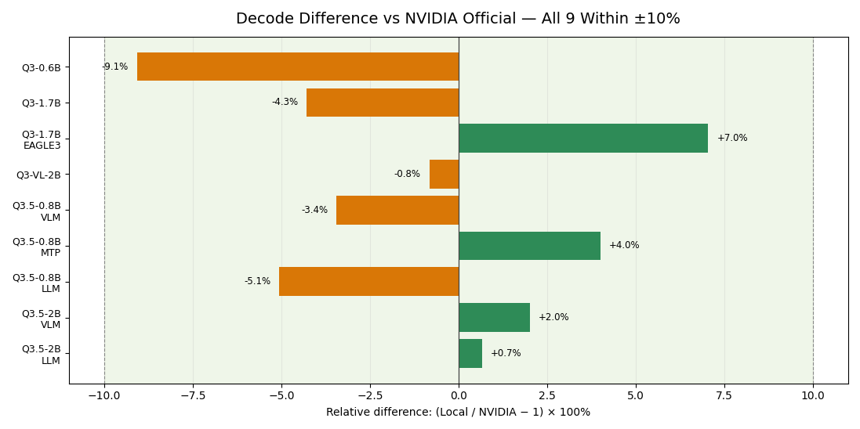  Description of Case Problems:  All 9 are within ±10%; mean difference is -1.0%. EAGLE3 acceptance 3.30/3.19; MTP 2.09/2.07 (local/official).
Judgment | Passed

